Text Preprocessing
- Lower case:
  - Whole document is to be converted to the lower case.
  - Ex: text.lower(), df[‘column’].lower()
- Remove un-important:
  - Remove the html tag, since tag i necessary for the browser, not for sentiment analysis.
    - Regular expression to remove the tags.
  - Remove urls - not important to sentiment analysis.
  - Removing punctuations.
    - These are used for the sake of making the sentence.
    - Tokenising - increase the document size, not helpful in model building.
    - Time take to preocess the text will be huge.
    - Df[‘column_name’].apply(function_name)
  - Chat word treatment:
    - Remove the social media based chatbot.
    - 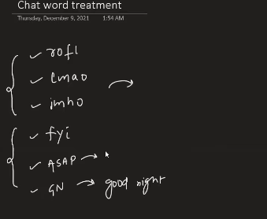
    - Solution : Dictionary.
  - Spelling correction:
    - Nltk, spacy, textblob - these are library to correct the text.
  - Removing stop words:
    - Do not have impact on sentiment analysis.
    - Help in making the sentence.
    - 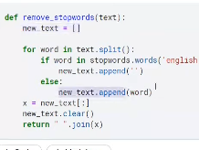
  - Handling emojis
    - No ML model can analsis.
    - Can remove emoji.
    - Replace with the emoji.
    - Can use dictionary.
    - 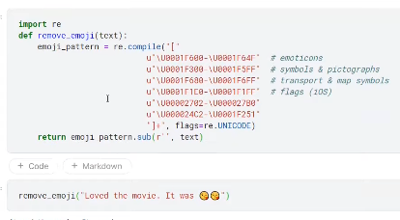
    - Import emjoi, then emoji.demojise(“text”)

- Tokenization( Dividing the larger text to smaller words/text ):
  - Word Tokenization:
    - 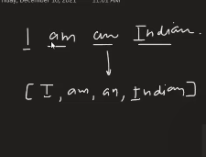
    - Mostly we do this.
  - Sentence toeknization;
    - 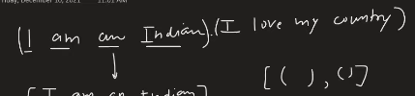
  - Text classification system:
    - Is it sales related -
    - Is it support related
    - New comes 2 times, even counted for 2 times, actual available is only one time.
    - 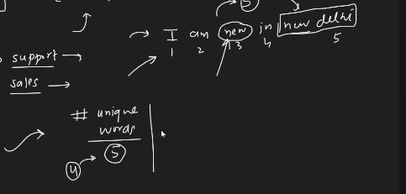
    - In future if tokenized wrongly, model do not perform properly.
    - 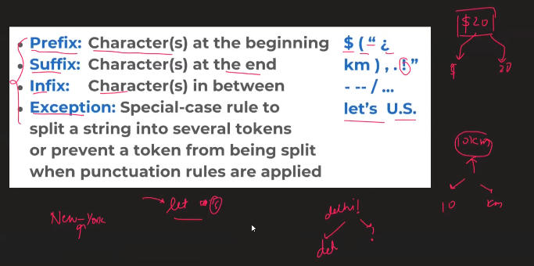
    - Just dividing by word itself is not enough, need to process it further use the algorithms.
    - There are many libraries(best)
      - Best - SPACY.
      - NLTK , word tokenize, sentenc toeknize.
      - There are many libraries.
    - Use regular expressions, split().
- Stemming;
  - 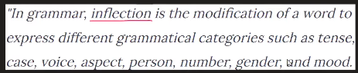
  - Inflection: Modifying the word to get the new meaning , to add for the tenses, etc.
  - Stemming : process of reducing the inflection, coming to the root word.
    - 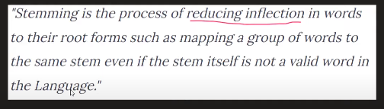
    - Helps in “Information retreival systems”
  - 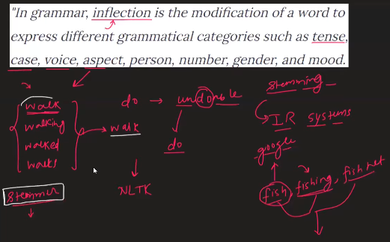
  - Porter stemmer, snowball stemmer.
  - PS
    - 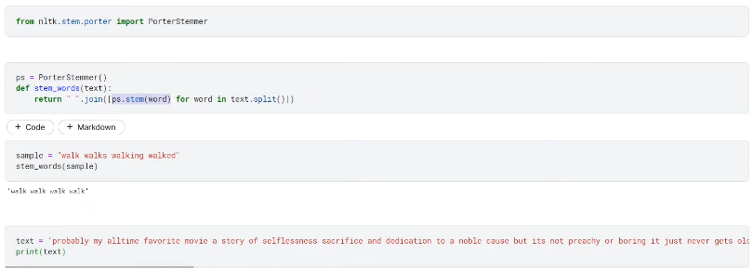
    - 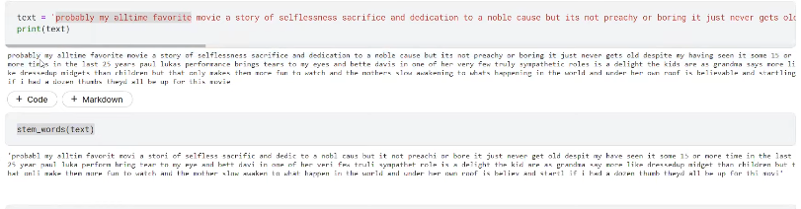
  - Sometimes the stemming output may not be in english word itself.
  - Hence we move on to lemmatization.
  - Lemma is quite slow, if you are showing the output to teh user, then we will be suing this , else we use the stemming.
  - If speed matters then we can use the lemmatization.
  - The stemming uses some algorithm to do it.

- Lemmatization
  - 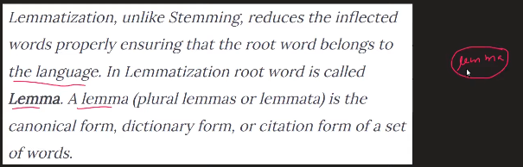
  - Uses wordnet dictionary.
  - Find the lemma from the dictionary.
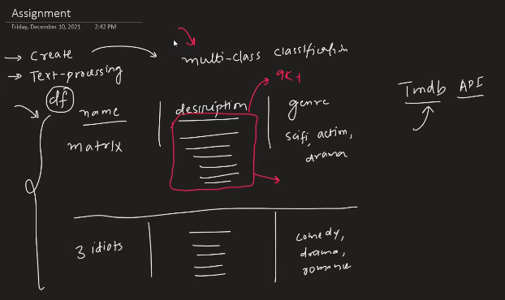

Text Representation

- What is Feature extraction from text?
  - Text to numbers
  - Also called:
    - Text vectorization.
    - Text representation.
  - Why needed:
    - ML algorithm always demands numbers.
    - We need to create feature usually in ML.
    - Statement: garbage in garbage out.
      - Even though the algorithm is great , but the input is very bad features, then we will be getting the bad result from the algorithms.
      - But even for a bad algo, give the features properly, still you will get better output than the previous.
      - Features are more important in machine learning.
    - We can extract the features like, what is the number of positive words in it, what is the number of negative words. What is the neutral words in it and what is the average of all the above.
    - We feed all of these to the machine learning algorithm.
    - So this is most important.
  - Photo : digit is seay, pixel is a number.
  - Speech:
    - input: waveform,
    - series points data is taken and stored to make the future predictions.

  - Textual data:
    - Direct representation like previous is not posisble.
    - So need to make one way to handle it.
    - But in such way, it must be able to convy the semantic meaning of it.
    - Customising of features:
      - What is the number of words, vowels, consonants etc.

Consider the IMDB dataset 49k , using this what to be done.
- Corpus(C):
  - Review and sentiment columns are there
  - Combining all the words in the dataset, is called the corpous.
  - Can be in lakhs
- Vocabulary(V):
  - Number of unique words in the corpous.
- Document(D):
  - Each and every individual review.
- Word(W):
  - Each word in the individual review/Document.

ONE HOT ENCODING

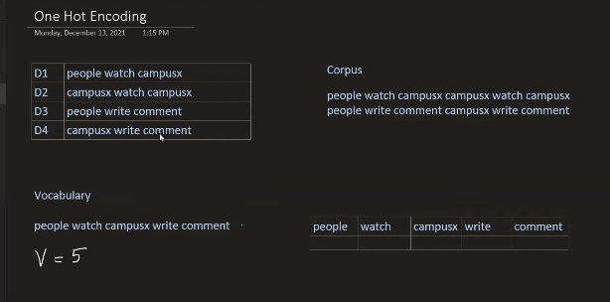
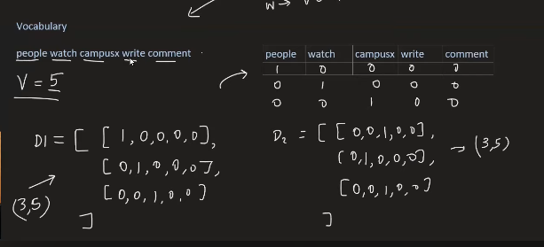
All the words in the corpous is converted to V sized vectors. Finally for all those words we combined to get the output from the document.
Disadvantage:
- Sparse : only one entry will be one and the rest will be zero, hnec there is chance of getting overfitted.
- Vary in the input, hence ML algo will not work properly.
    - 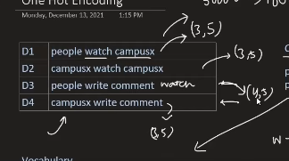
- Out of vocabulary.
- No semantic meaning is captured.
    - 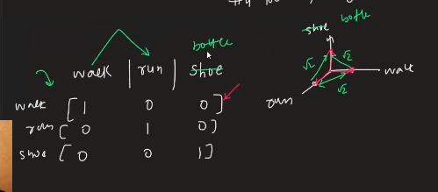
    - Walk and run are more claser, so the distance between these 2 must be small and the bottle and must be far from walk and run, but that is not happening here.

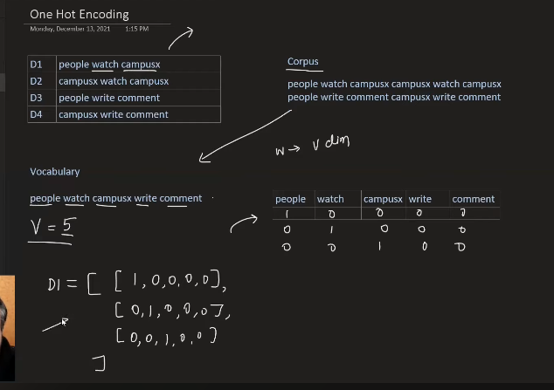
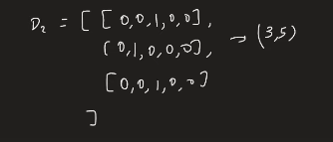
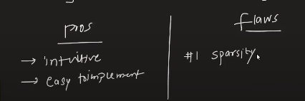
Problems
- Sparsity:
  - Usually in the real world there will be 1000s of the words within an document, and the unique number of words in the whole corpous will be like hell. In that scenarios, making the OHE even on one document will be like introducing many number of zeros in the whole array. Hence makes the sparsity. This introduces the overfitting.

- The change the shape or dimension.
  - ALL the ML models will work only if we have same number of input dimensions.
  - If there is not fixed size then we will have to suffer.

3. Prediction(Out Of Vocabulary):
  - When many new word comes during the testing phase all of them cannot be represented at all.
  - Even though we use the zero padding, still we will be making the every new word to be same representation. All with just zero entries.
  - Hence prediction will not work at all.
4. No capturing of semantic meaning
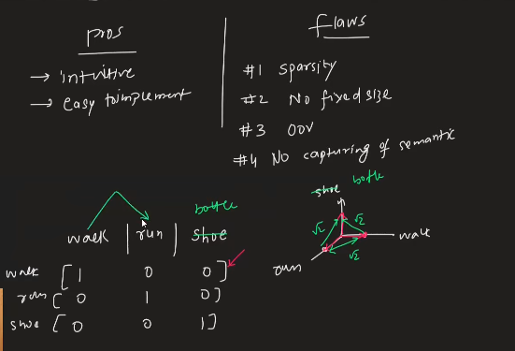
All of them are represented with the same meaning, it cannot capture the meaning. All of them are at the same distance.
Infact walk and run must be closer to each other. But the distance between the bottle and the other things must be different.
Cannot capture the meaning of semantic / sentence meaning.

Bag of words
- According to research, it is best for text classification tasks. Like news , fight, politics, document classififcation.
- Steps:
  - Create the vocabulary based in the input.
  - Take the document one by one then start making the entry, if the vocabulary is seen then the value in that has to be increased. If the word is seen in document then that entry value to be increased in the document.
  - Core inptuition: The simmiliart type of the document will be having the similiar type of bag of words ususally.
  - Finnaly a document is captutred to a v dimensional document.
  - When it is placed in teh space the dimesion betweenn th e similair type of documents are less sepeartaed in terms of angle when compared to differnt types of the document.
  - Similarity: cos angle between the bag of words vector.
  - Finally the original data vector which is nearby the testing or predicting, that label is assigned.
  - Similairty is calculated bsed on the cos of angle
- Advantage:
  - Simple and intuitive
  - Fixed vector size.
  - OOV handled.
  - Semantic meaning is little bit is captyred, better than OHE.
- Disadvantage:
  - Sparsity – overfitting.
  - Order of words does not matter, since the order matters, hence the meaning matters.
  - Information loss – oov.
  - 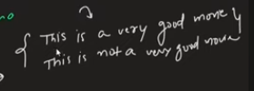
    - Because of this BOW, logic makes these sentence are kept closely.

Sentiment analysis:
  - 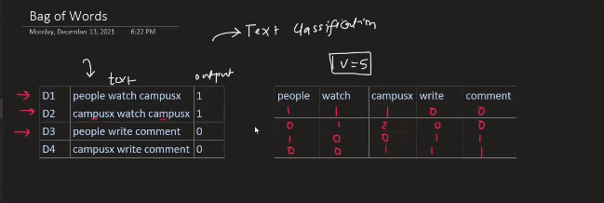

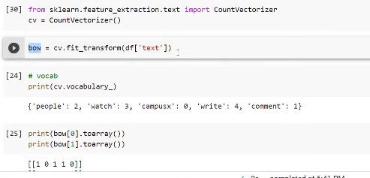
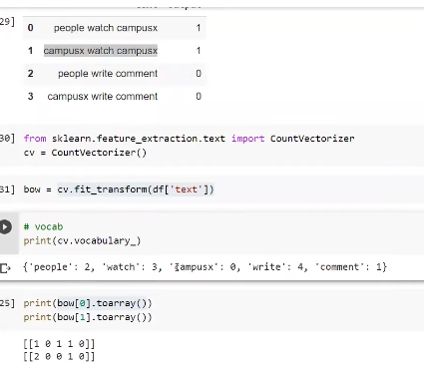
Suppose if the out of vocaubulary is seen then those kind of words are ignored.
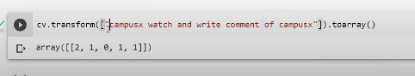
Hyper parameers:
Binary = True, is set as the hyper parameter, then essentially if any vector whose entry is more than one then that is made 1.
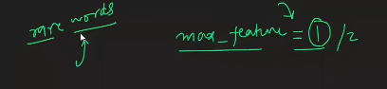 if one, then only ‘campusx’ is choosen because in the whole document campus-x is seen more number of times, compared to the other. If 2, then [campus x , watch ], is considered.

BAG OF N-GRAMS
This is called bag of n-grams
Till now the vocabulary is made using the single word. Because of this odering of the words cannot be utilised, but the ngrams will solve this problem.
Bigram: We take 2 words as one vocabulary
Trigram: We take 3 words as one vocabulary
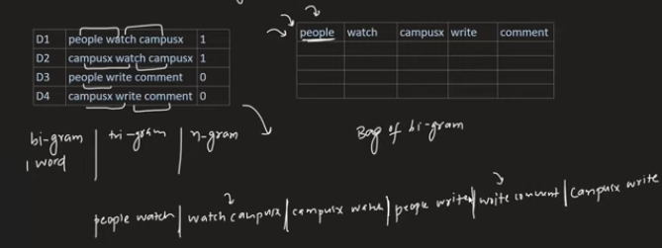
The below one in image is the bigram of the vocabulary.
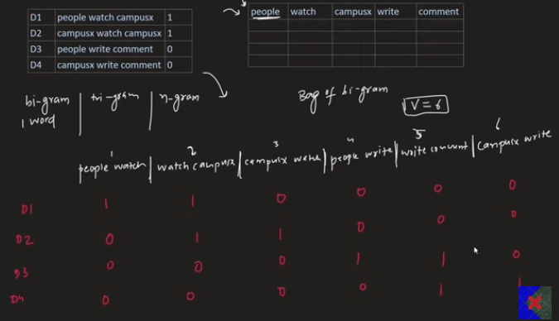
Trigrams;
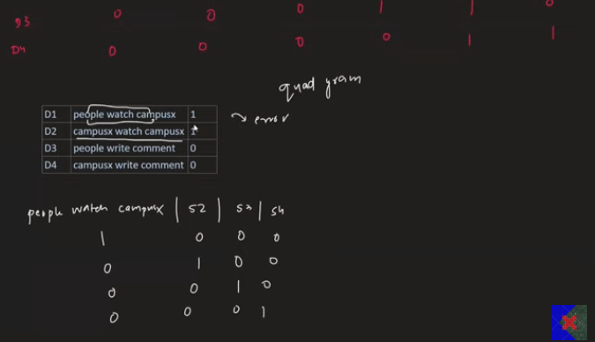
Quad-gram is not possible , since non of the sentence with the word more than 3.
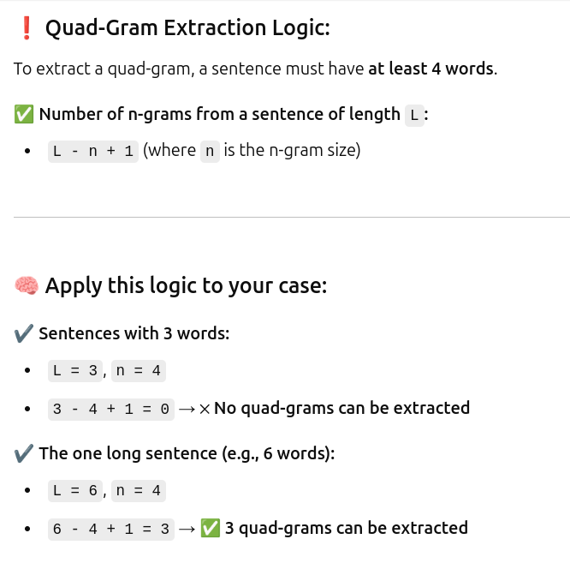
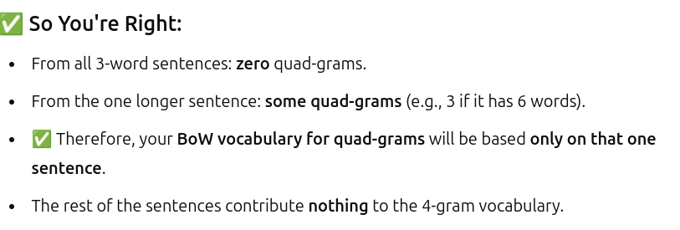
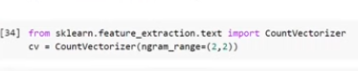
It is pure bi grams
Is the tuple is (1,2) - then the corpous is the combination of both uni and bigram
(1,3) - combination of one 2 and 3gram , is prduced as vocuabulary.

Unigram
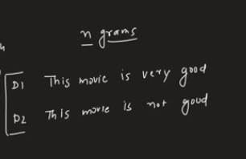
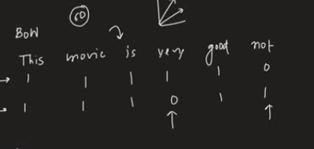

2gram
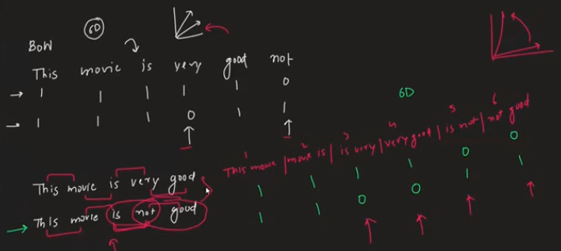

Advantage of n-grams:
- Able to capture the semantic meaning of the sentence.
- Easy implmentation
Disadvantage:
- Number of vocabulary increase with the grams increases which increases the dimensionality, which in turn increases the computation in order to find and fit the model.
- OOV is ignored.

TF-IDF

- 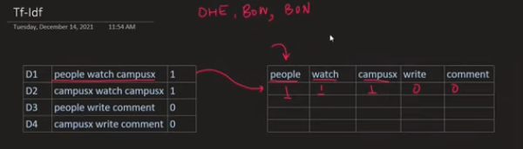
  - The numbers representing the above is making the equal weights to every term.
  - But the weightage should be given in different way in such a way that it has to make sense.
- If any word is more in the single sentence , but it very rare in the document, means the particular word is more important in the document, hence it has to be given the higher values in the current document, compared to other words in the docuemt.

- Term Frequency:
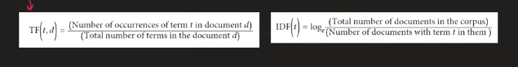
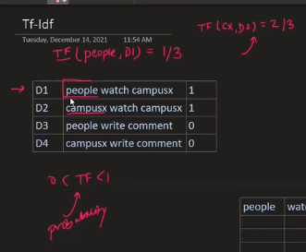
This TF is also called as the probability, because the value of this is always lie between 0 and 1.

- Inverse document Frequency:
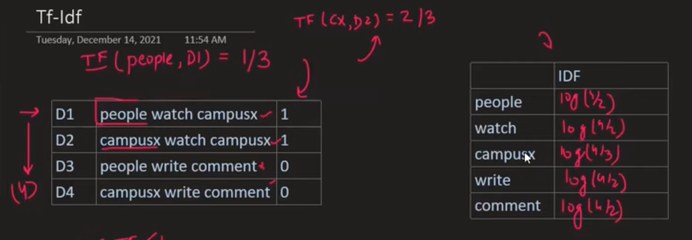
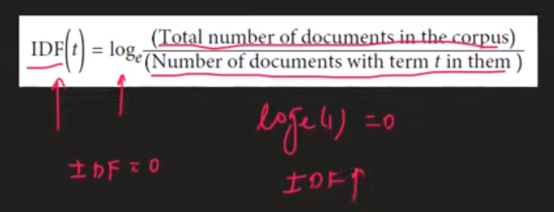
If the term is seen with every document in the corpous, then that idf is considered to be zero.
If the term is seen only with one document in the the whole corpous, then the idf would be great.
Hence TF*IDF, is the result or weight, for every word in the corpous.
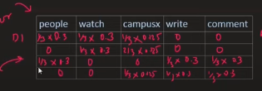
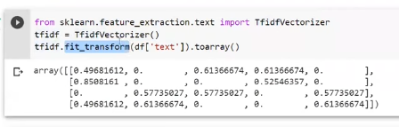
Idf remains the same, only things that is going to change is tf.
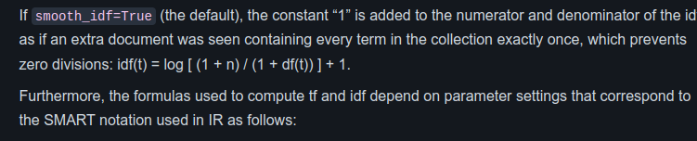

Why log is considered in the time of calculating the idf ?
There are some words whose values which are going to appear in every sentence of the document. Then it is considered IDF=1. If once in a document of the whole corpous of the sentence =10000, then that value would be 10k in the idf, if IDF=(N/n), hence by multplying that with the tf ,making the formula tf*idf, will make the tf to ignore totally, tf will not have the effect at all.
Hence to prevent it, we make use of the log along with the idf.
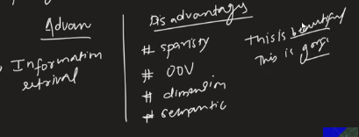

Custom Features
This is done by us, manually in the review.
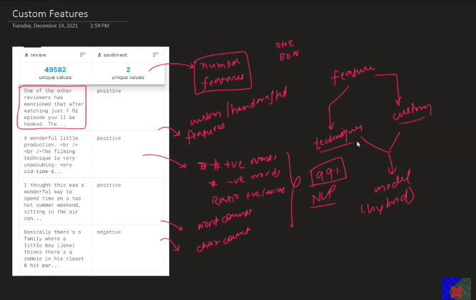
WORD EMBEDDING
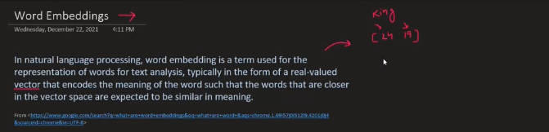
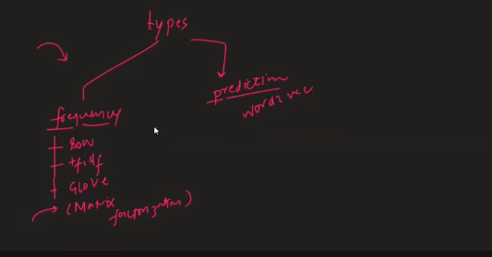
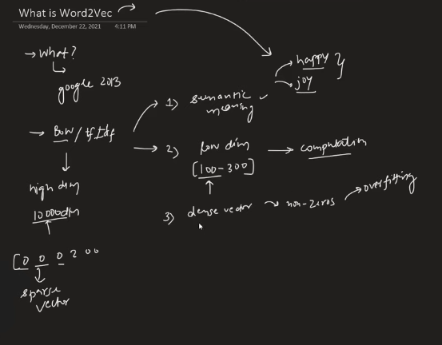
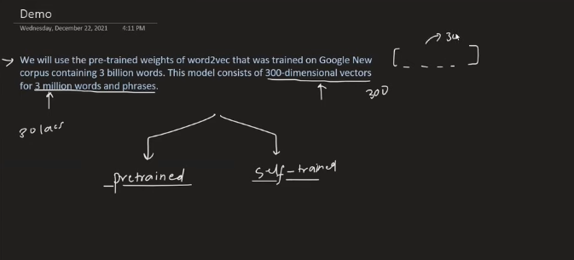
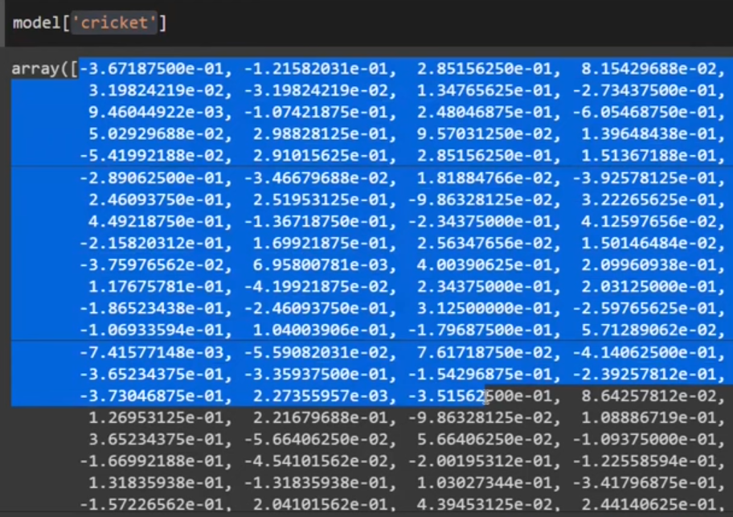
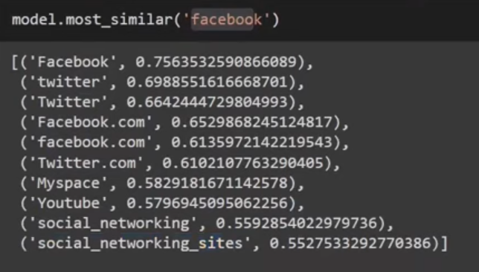
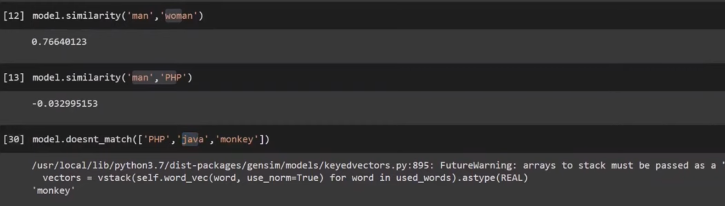
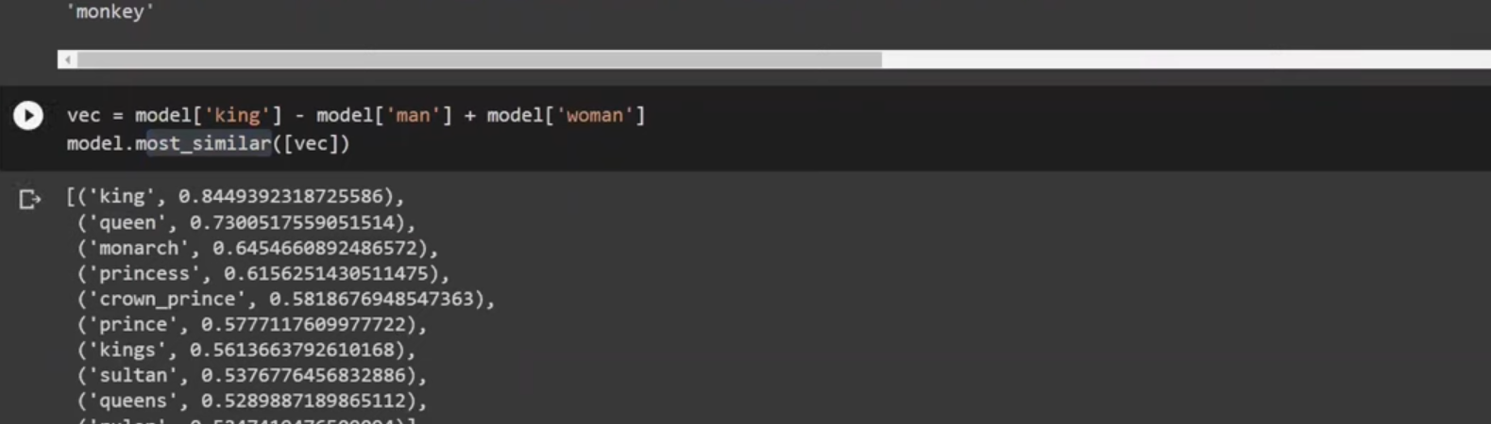
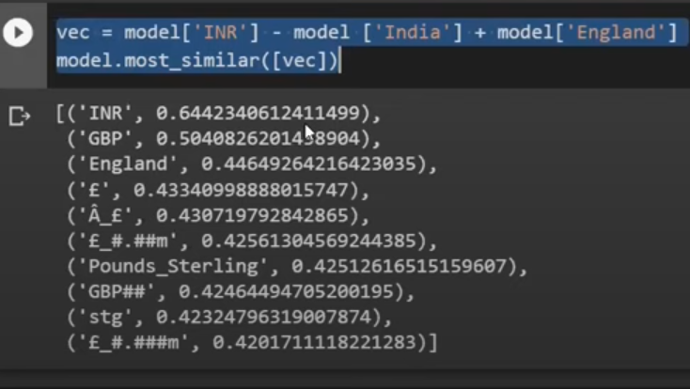
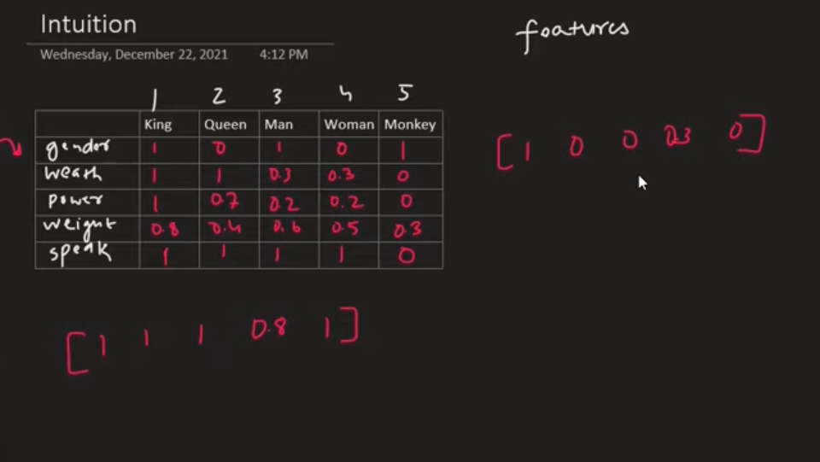
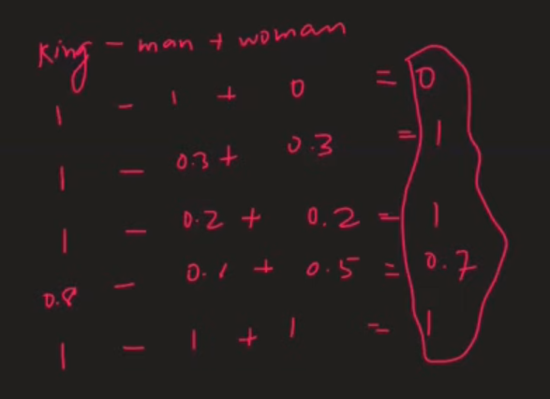
Problem: When embedding vector is built using the neural network, we will not get to know what is going on. What dimension representing what feature, whether that is ears, eyes, weight, gender, these things will be on the embeded dimension but we will not be knowing which dimensioned value in the vector is repreenting what? Automatic NN builds the vector of 300 D, vector.
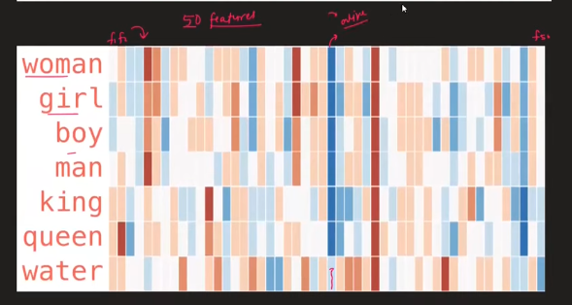
The blue feature in the middle can be alive feature. Hence except water everybody sharing the same value.
What they did is, took 300 feaures, among the top 50 is used for the sake the printing using color. Blue representing the value in negative, red representing the value in positive.
What feature is telling we cannot say, but try to make it by using the comparision.
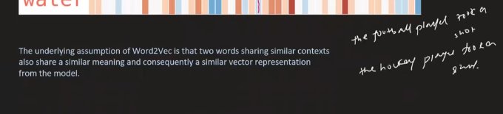
Considers football and hockey are similiar to each other.
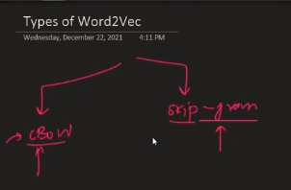
Different types of architecture in word2vec.

CBOW(Continous Bag of Word)

- We do not convert word to vec, we take a fake problem, as a by produce we get the vector.
- 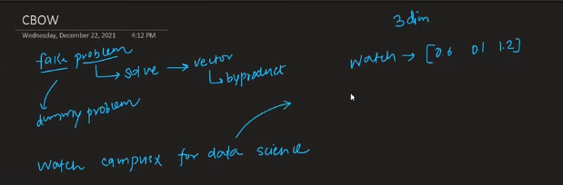
  - The above is the target, convert from word to vector.
- This will be just the prediction problem, we consider the assumtion that the center word is the prediction word and the words around the center is the context word.
  - Beacasue in definition, 2 words sharing the similar context will be sharing the similiar meaning.
  - Window is 3 word context window, 2 side by side, 1 center. 5 context window size, 2 words on each side is the context words, the center is the target.
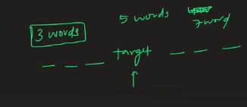
  - Sliding window of the size mentioned to be considered.
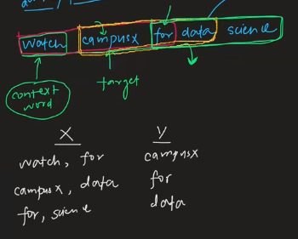
Based on x and y, we make the deep learning model.
- Steps:
  - Convert every word to one hot encoder.
  - Build the NN.
  - The middle is 3 nodes because of the sliding window size taken as 3. (Not true, but was told like that.)
  - At last there is 5 neuron output, because of the the vocabulary size
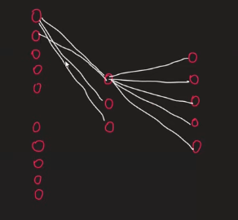
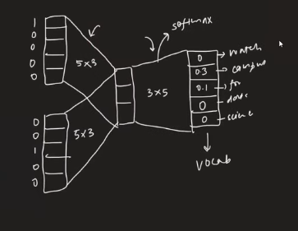
Neural network, conncepts like back propagate.

The center part is the embeding.

watch word embedding:
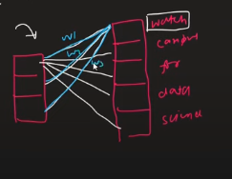
For word embedding:
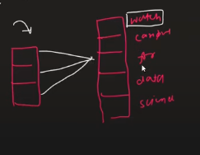
Hence the embeding is my hyper parameter

SKIP GRAM
This is reverse of the CBOW
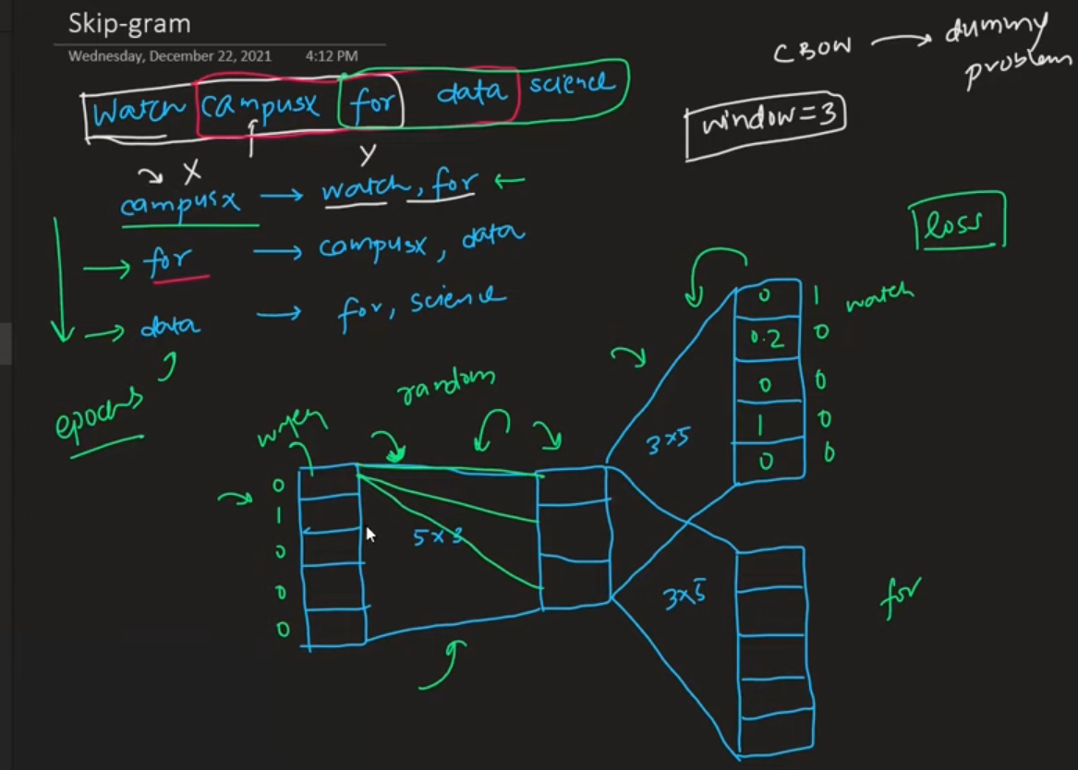
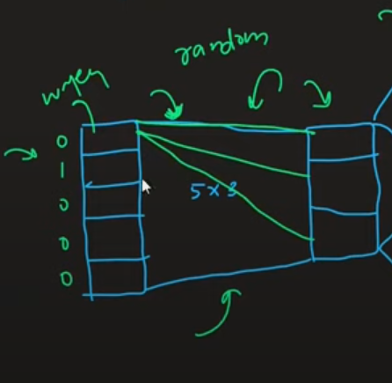
This is embedings

When to use CBOW and when to use Skip Gram?
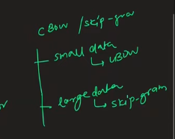

Improve the embedings?
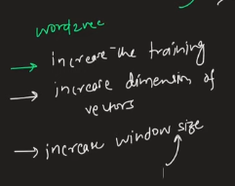

Code
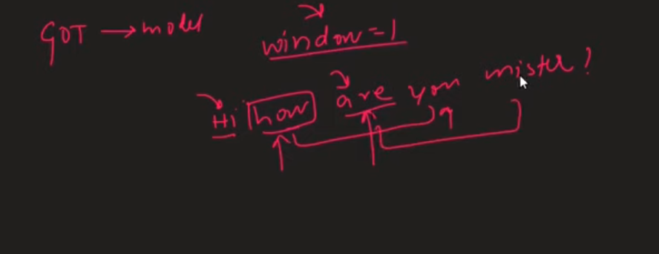
TEXT CLASSIFICATION
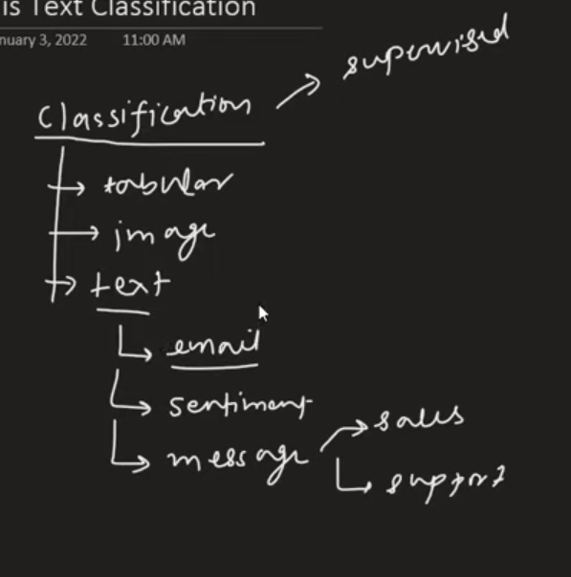
Input can be sentence of the document, whataver ot could be.
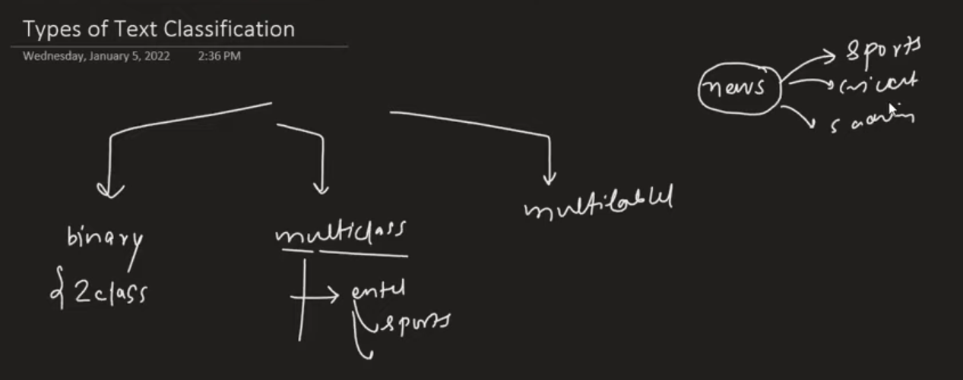
POS TAGGING
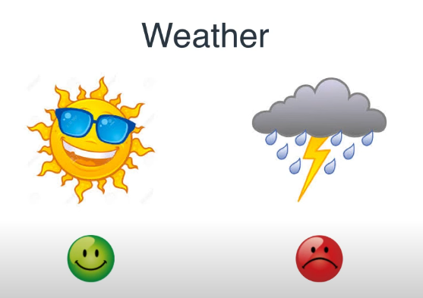
Deciding mood based on environment
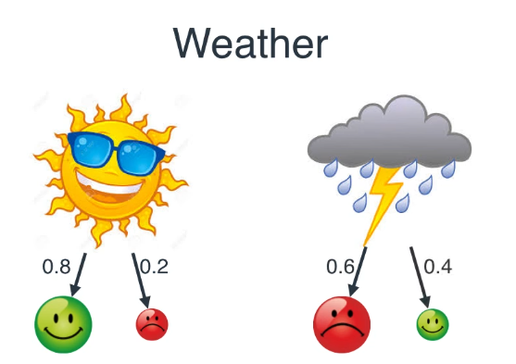

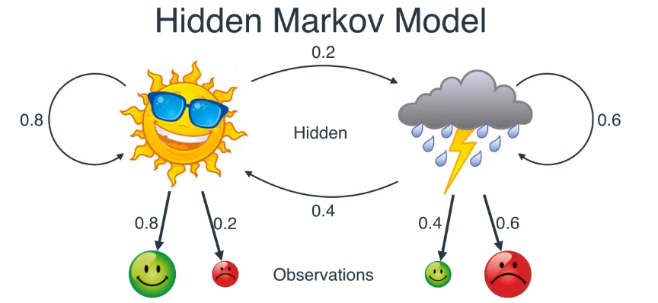
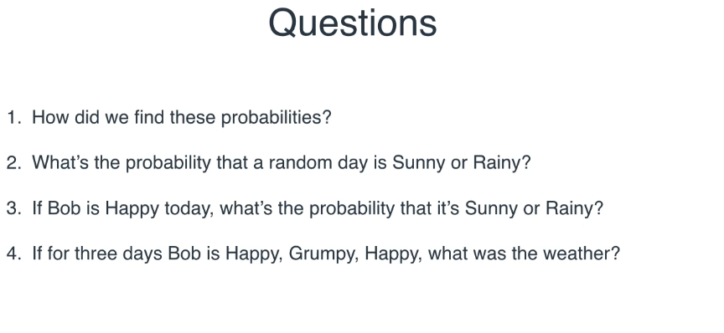
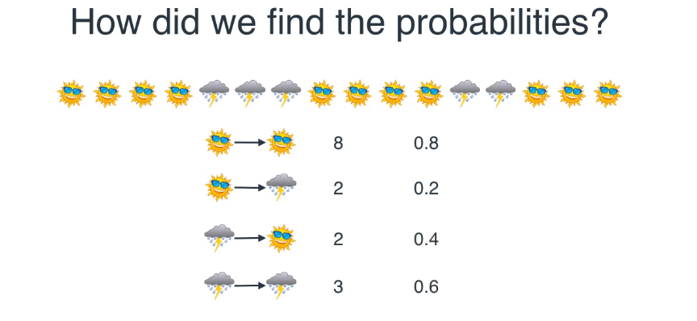
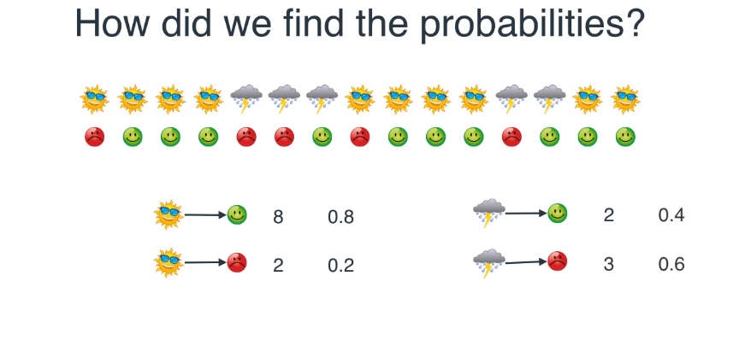
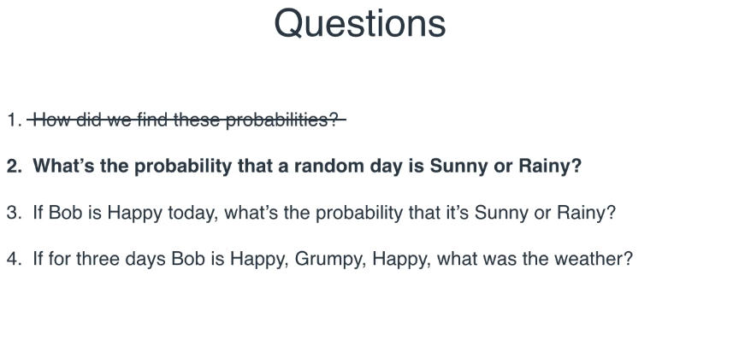
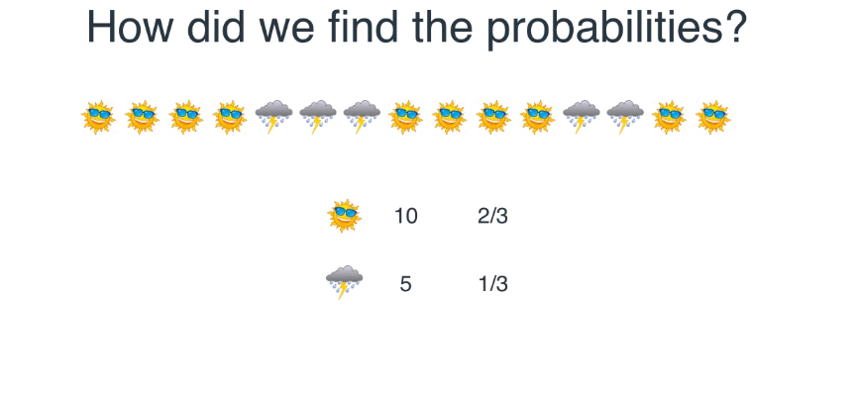
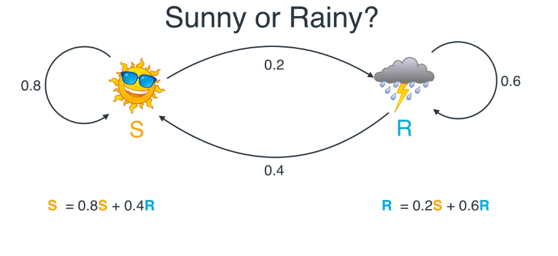
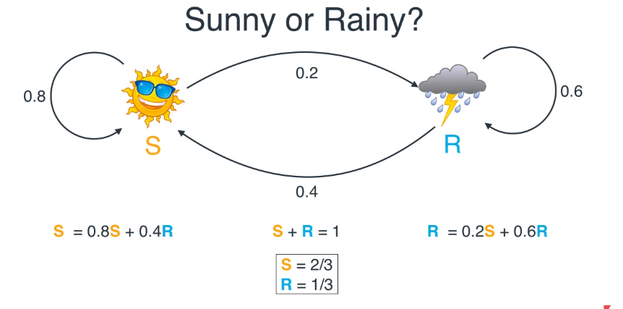
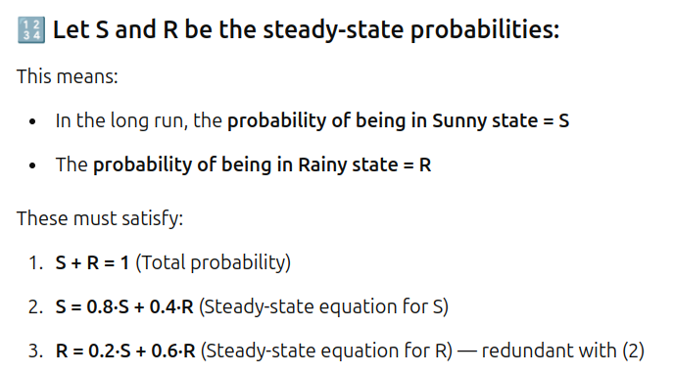
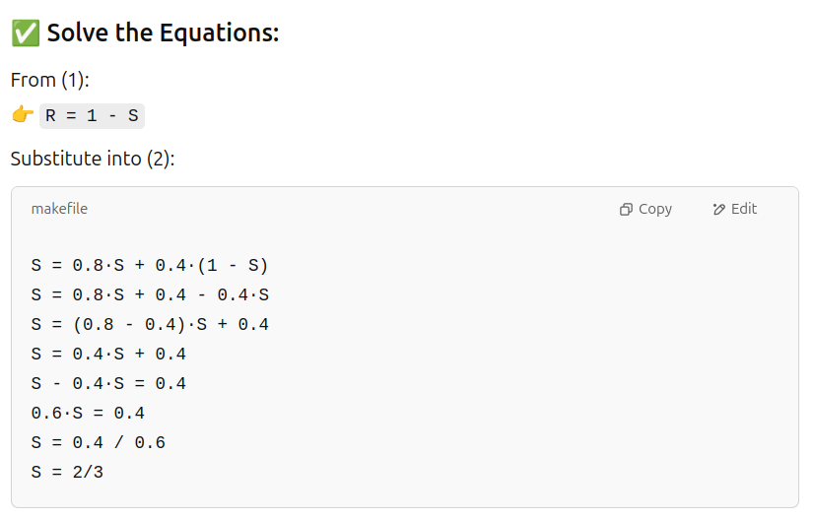
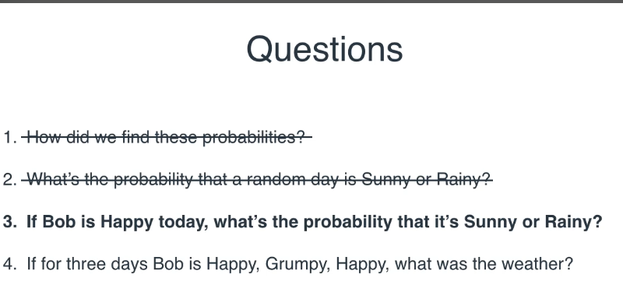
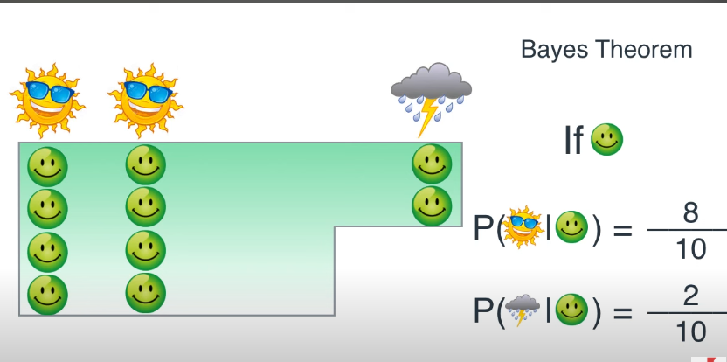
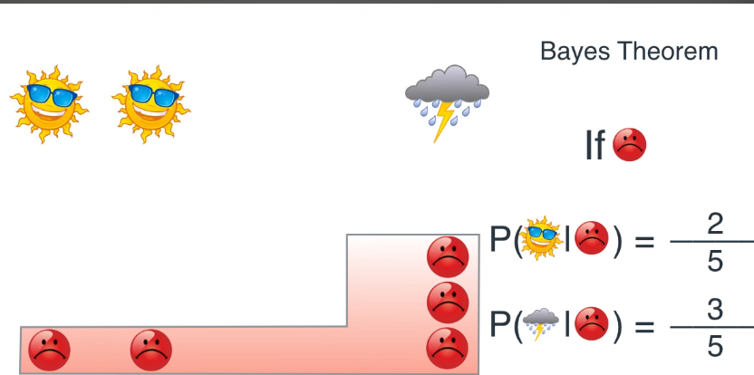
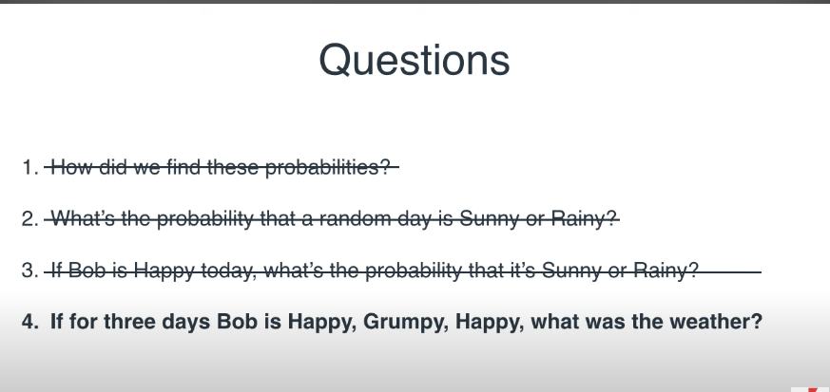
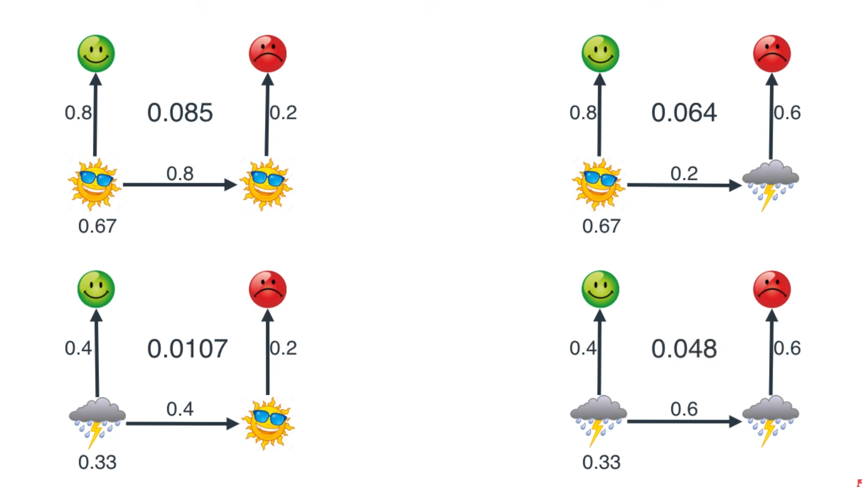

- S

